Healthy Eating Information for Parents and Carers:
Coming in to contact with a range of different foods from an early age makes children less likely to be fussy eaters. This means they will be more likely to eat fruits, vegetables and other healthy foods. This is important because a healthy diet gives them the range of nutrients, vitamins and minerals they need to grow.
NHS Start4Life has information about weaning, healthy foods and activities for babies and toddlers
NHS Change4Life has tips and activities for families to make healthy food swaps, recipes, snack time ideas, 10 minute shake up activities, and to download the Food Scanner to find out what’s really inside your food
Healthy Feeding, Healthy Weight information guide by Portsmouth and South East Hampshire NHS maternity services

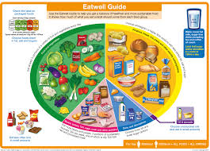
Healthy Eating
The Eatwell Guide booklet illustrates the different food groups
First Steps Nutrition Eating Well in the Early Years: information to help families choose healthy options. Explore the guides on:
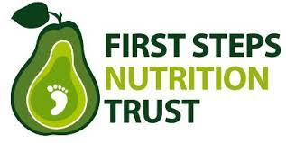
- healthy snacks,
- portion sizes for tiny tummies,
- packed lunches, and
- eating well recipes.
NHS family tips to eat at least 5 fruits and veggies every day, and What to feed young children guide
Healthy Eating Top Tips from Family Lives
5532 Portion Size Poster by British Nutrition Foundation
Understanding food labels guide
Healthy eating out guide from NHS
Drinks and cups for babies and young children information from the NHS
Food safety and hygiene: How to stay safe

Breastfeeding
Here are some independent unbiased organisations for support with breastfeeding:
https://www.laleche.org.uk/
https://www.breastfeedingnetwork.org.uk/
https://abm.me.uk/
https://www.unicef.org.uk/babyfriendly/support-for-parents/

Introducing solid foods
Introducing solid foods video from NHS Choices
Top tips video from Start4Life
NHS information on your baby’s first solid foods
NHS information on food allergies

Lunch Boxes
Explore NHS ideas for a healthier lunch box
Eat Better, Start Better practical guide for parents and carers on healthy packed lunches for Early Years.
15 Easy and nutritious lunchbox ideas from BBC Bitesize

Fussy Eaters
NHS advice for fussy eaters
Coping with fussy eaters advice from Family Lives
Information to help with common feeding pitfalls with children by the Child Feeding Guide

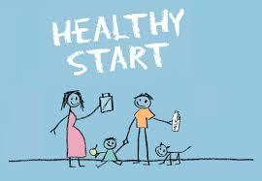
Other support and information
Healthy Start vouchers information for free vitamins and healthy food for young children and pregnant women
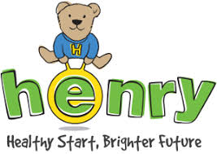
Information, activity and recipe ideas for parents and carers from HENRY. HENRY group sessions also run across Hampshire.
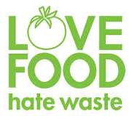
Love Food Hate Waste tips and recipe ideas to help reduce your food waste
Cbeebies Mr Bloom’s Nursery for ideas and tips of growing veggies, craft activities and more.

