Beaumont Community Preschool
& Childcare Groups
Prospectus

The Old Guard Rooms
Beaumont Grove
Aldershot, Hampshire
GU11 1YH
Tel/Fax: 01252 328375
E-mail: beaumontgroups1@aol.co.uk
Website: beaumontpreschool.com

Bumbles Opening Times:
9am – 3pm
Session Times 9am-12pm and 12pm – 3pm
Age Range: 3 months to 3 years old

Preschool Opening Times:
9:15am – 3:15pm
Session Times 9:15am – 12:15pm and 12:15pm- 3:15pm
Age Range: 3 years to 5 years old

We can offer flexible session times to meet your needs
We are term time only, open Monday to Friday, 38 weeks a year

We were rated GOOD on our last Ofsted inspection in January 2018
https://reports.ofsted.gov.uk/inspection-reports/find-inspection-report/provider/CARE/109947
Your child at the heart of our care
You are bound to feel a little apprehensive about leaving your child at preschool for the first time – every parent does. That is why it is important that you are completely comfortable with the child care you choose.
We aim to help put your mind at rest by providing a safe, loving and stimulating environment for your child. With high standards of care and excellent facilities, we can provide the individual attention and stimulus your child needs to feel happy and confident when in our care.
Our aim is to help your child develop physically, socially and emotionally – and ultimately prepare them for school.
Our qualified and experienced staff teams plan warm and welcoming environments which provide the experiences from which children learn. The relationship between children and staff at our setting is based on respect and trust.
We welcome children from the age of three months to five years and we recognise that they all have very different needs. This depends not just on how old they are, but also on individual personality and ability.
We take the greatest care to provide the right level of support and encouragement, so your child can grow in confidence, build on important social skills and learn at their own pace.
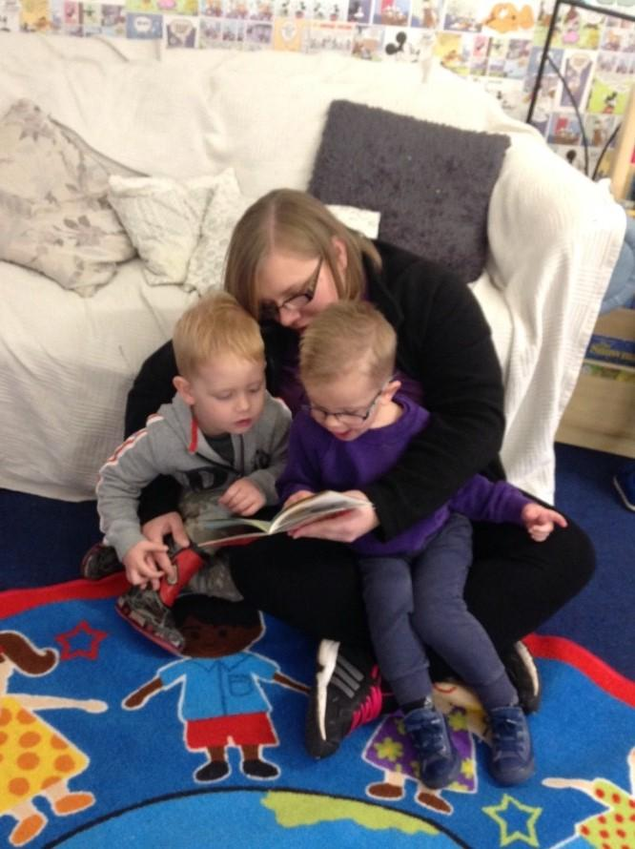
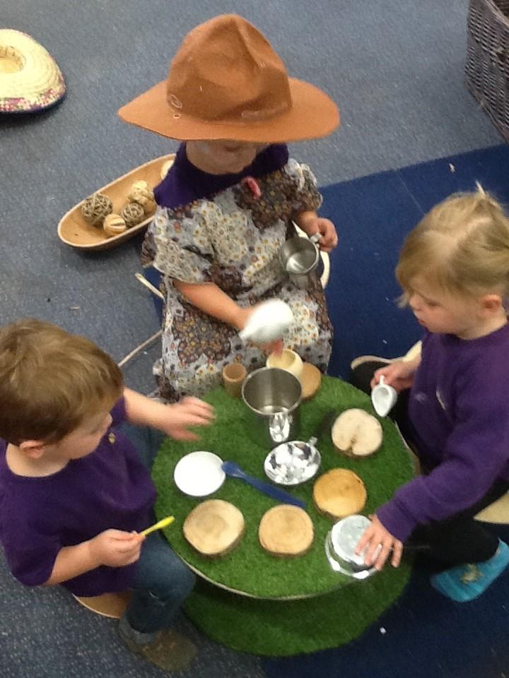

Our Setting
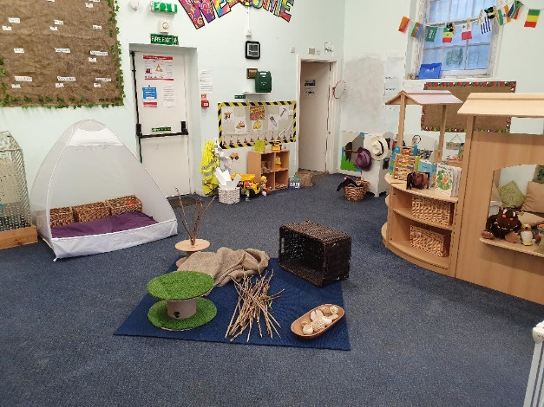
Bumbles (Ages 3 months to 3 years)
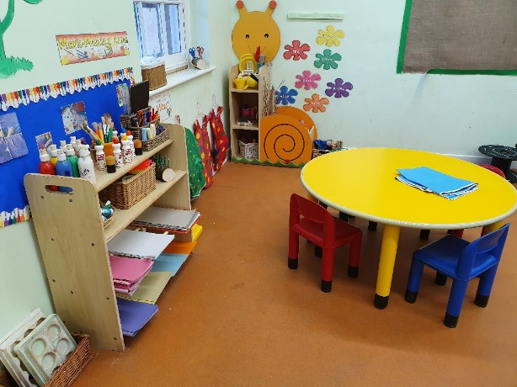

Preschool (Beehives- 3years to 5 years0
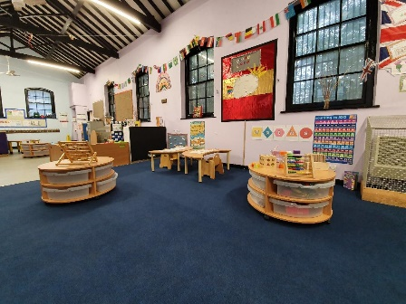
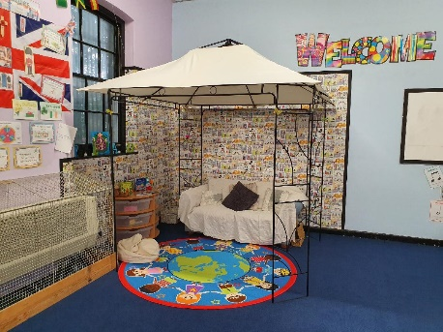

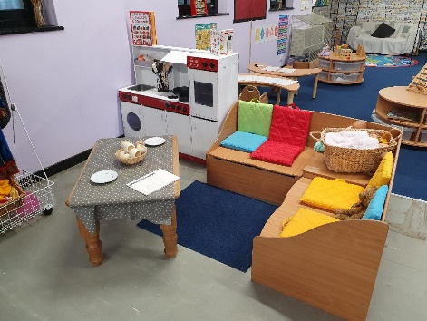

Outdoor Courtyard
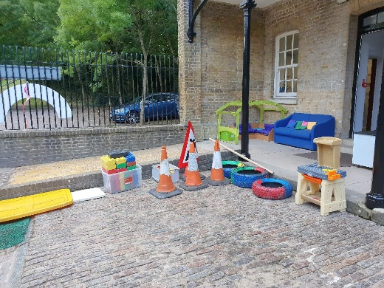
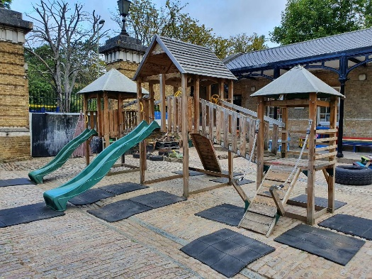

The Committee

The setting is run by a voluntary committee of parents and carers. Committee members are the charity trustees of the setting and together they are responsible for the overall management and smooth-running of the setting.
The committee consists of a Chairperson; Secretary and Treasurer as well as other members who are involved in fund raising and supporting of developments within the preschool setting it also gives parents/carers a greater involvement in the vitally important early stages of your child’s/children’s education.

Parental Involvement
Children are happier when the adults in their life work together as part of a team. As parents, you are part of a two-way process of sharing knowledge and information about your children.
We want to work closely with you, drawing upon your detailed knowledge of your child. We ask you to fill in an admission form, providing details about your child and any relevant medical history, as well as an all about me information form, which establishes a starting point for your child’s learning.
We operate an ‘open door’ policy. Parents and carers are welcome to join us at any time during the pre-school session, however are not included in the staff ratio. Regular newsletters are sent home with details of current news and future events. As a charitable organisation, we hold a variety of fundraising events, such as summer fayre, disco, fun days and are always looking for new ideas from parents.
All parents are invited to join the committee, made up of parents and friends of the pre-school

Structure of the setting

Management

Nicole Breakwell BA (Hons) – Manager; Designated Safeguarding Lead
Kate Vass BA (Hons) – Deputy Manager; Designated Safeguarding Lead/Health & Safety Officer

Office
Leanne Smith – Office Manager and Fire Safety Officer.

Preschool 3yr-5yrs
Natalie Gibbons (Level 3) – Room Leader
Lauren Moore – Deputy Room Leader; Behaviour Co-ordinator/Inclusion Officer
Abbie Medway (Level 3) – First Aid Co-ordinator
Sharon Richards (Level 3)
Chris Whitehead (Level 3)
Toomey Donachie (Level 3)
Diane Watts

Bumbles 3mths-3yrs
Louise Brenton (Level 3) – Room Leader and Inclusion Officer and 2 year old funding lead
Helen Costigan

Our Curriculum and Learning
The Early Years Foundation Stage
The Early Years Foundation Stage (EYFS) sets standards for the learning, development and care of children from birth to 5 years old
The Early Years Foundation Stage (EYFS) framework supports an integrated approach to early learning and care. It gives all professionals a set of common principles and commitments to deliver quality early education and childcare experiences to all children.
For more info:
Development Matters
http://www.foundationyears.org.uk/files/2012/03/Development-Matters-FINAL-PRINT-AMENDED.pdf
Statutory Framework
https://www.foundationyears.org.uk/files/2017/03/EYFS_STATUTORY_FRAMEWORK_2017.pdf

Tapestry
Beaumont Community Preschool uses an easy-to-use secure online learning journal.
Tapestry helps educators and parents to record, track and celebrate children's progress in early years education.
This unique journal is shared securely online with parents where parents and carers are given their own log-in details to see special moments and view their child's progress as well as add their own special moments.
Tapestry enhances special times, helping practitioners to capture children’s experiences as well as monitor development and learning.
For more info: https://tapestry.info/
Policies and Procedures

There are policies and procedures in place within the setting that are in line with Ofsted and the EYFS Statutory requirements, policies are accessible via our website page, or if you would like to take them home copies can be given upon request.

Safeguarding
At Beaumont Community Preschool & Childcare Groups are committed to safeguarding children and promoting the welfare of children and young people the welfare of the children within our care is of paramount importance and we will aim to do everything we reasonably can to fulfil our ‘duty of care’ towards the children who attend our setting.
Beaumont Community Preschool & Childcare Groups will work with children; parents and the community to ensure the rights and safety of children and to give them the very best start in life. As a setting we expect all employees, workers, students and volunteers to share this commitment.
All our staff have a current DBS and have training or an understanding of Safeguarding Children/Child Protection issues. We also have Designated Safeguarding Leads within the setting.
(Please see our Safeguarding policies for more information).

Health & Safety and Fire Safety
Our setting believes that the wellbeing of children is of paramount importance.
We aim to make children, parents and staff aware of health and safety issues and to minimise the hazards and risks to enable the children to thrive in a healthy and safe environment.
We also have Health & Safety Co-ordinators within the setting that monitors health and safety issues.
Any accident/incident your child may incur whilst in our care will be recorded, however minor. Parents will be informed and asked to sign the record in acknowledgement.
Following our policies and procedures we will also record injuries that the child has attended the setting with (Existing Injuries)

We ensure our premises present no risk of fire by ensuring the highest possible standard of fire precautions for example carrying out regular fire drills.
We also have a Fire Safety Officer and the person in charge and staff are familiar with the current legal requirements.

Policies and Procedures
Security & Safety
- Entry to the setting is through the main gate with Bumbles to the far left and Preschool to the right of entry, the main doors are secure and locked during sessions. The main gate is securely double locked during the whole session.
- Parents and carers must collect their children at the agreed time, and parents must give prior notice if anyone other than the named carer collects a child.
- You will be asked to provide a password at registration, which must be used if another authorised adult collects your child.
- For the safety of your child we will not release your child without a password or prior notification, and on initial collection from an authorised adult, we will need to see identification.
Ratios
Our ratio of staff to children is

- 1 staff member to 6 children for over 3 year olds
(The Ofsted ratio requirement is 1:8)
- 1 staff member to every 4 children for under 3 year olds
- 1 staff member for every 3 children for under 2 year olds

Confidentiality and Information Sharing

‘Confidential information is information of some sensitivity, which is not already lawfully in the public domain or readily available from another public source, and which has been shared in a relationship where the person giving the information understood it would not be shared with others.’

At Beaumont Community Preschool and Childcare Groups, staff and managers can be said to have a ‘confidential relationship’ with families. It is our intention to respect the privacy of children and their parents and carers, while ensuring that they access high quality early years care and education in our setting. We aim to ensure that all parents and carers can share their information in the confidence that it will only be used to enhance the welfare of their children.
There are record keeping systems in place that meet legal requirements; means of storing and sharing that information take place within the framework of the Data Protection Act and the Human Rights Act.

The role of the key person
At Beaumont Community Preschool we offer children and their families settling in periods which are flexible to your child’s needs and wellbeing, we also have a keyperson system where every child is allocated a keyperson. We believe that children settle best when they have a key person to relate to, who knows them and their parents well, and who can meet their individual needs.
Research shows that a key person approach benefits the child, the parents, the staff and the setting by providing secure relationships in which children thrive. We want children to feel safe, stimulated and happy in the setting and to feel secure and comfortable with staff. We also want parents to have confidence in both their children's well-being and their role as active partners with the setting.
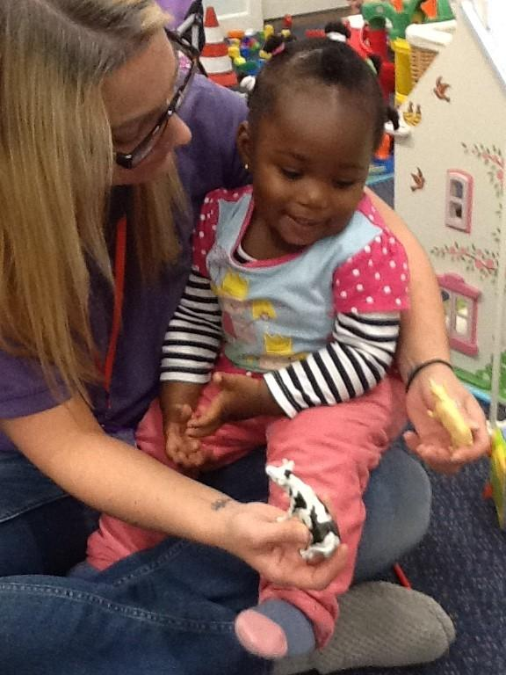
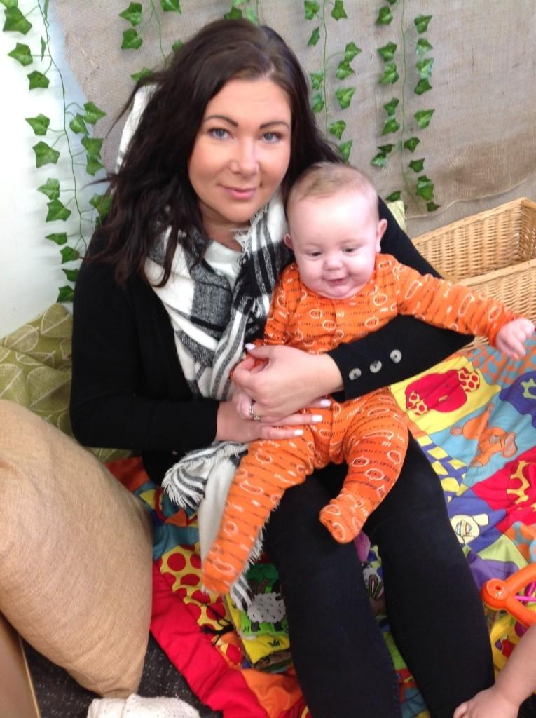

Supporting children with additional educational needs
Beaumont Community Preschool & Childcare Groups provide a fully inclusive environment in which all children, including those with special/additional educational needs, are supported to reach their full potential.
We have regard for the Special Educational Needs & Disability Code of Practice and have a specific designated Inclusion officer within the setting.
We support parents and children with additional needs and identify the specific needs of the children and meet those requirements through a range of SEN strategies, working in partnership with parents and other agencies such as the Hampshire Area Inclusion Officer in meeting individual children's needs. The role of the Area Inco can be found at:
www.hants.gov.uk
At Beaumont Community Preschool & Childcare Groups we aim to offer excellence and choice to all our children, whatever their ability or need.
We have high expectations of all our children and aim to achieve this through the removal of barriers to learning and participation.
We want all our children to feel that they are a valued part of our setting.
www.fish.hants.gov.uk

Looked after children
Beaumont Community Preschool & Childcare Groups are committed to providing quality provision based on equality of opportunity for all children and their families. All staff in Beaumont Community Preschool & Childcare Groups are committed to doing all they can to enable ‘looked after’ children in their care to achieve and reach their full potential.

Valuing diversity and promoting equality
Beaumont Community Preschool & Childcare Groups promotes equality and diversity welcoming all families from all areas of the community.
We celebrate a variety of backgrounds, cultures and celebrations valuing everyone’s opinions and beliefs

Achieving positive behaviour
Beaumont Community Preschool & Childcare Groups believe that children flourish best when their personal, social and emotional needs are met and where there are clear and developmentally appropriate expectations for their behaviour.

Children need to learn to consider the views and feelings, needs and rights, of others and the impact that their behaviour has on people, places and objects. This is a developmental task that requires support, encouragement, teaching and setting the correct example. The principles that underpin how we achieve positive and considerate behaviour exist within the programme for promoting personal, social and emotional development.

We are respectful of and recognise that codes for interacting with other people vary between cultures and we support all children in developing a sense of belonging in our group, so that they feel valued and welcome, whilst developing their self-esteem, confidence and feelings of competence.
All who work with the children provide a positive model of behaviour by treating children, parents and one another with friendliness, care and courtesy.

Promoting alternative thinking strategies (paths)
At Beaumont Community Preschool & Childcare Groups we use a programme for over 3 year olds that empowers all children to develop the fundamental social and emotional learning skills which will enable them to make positive choices throughout life. It is designed to facilitate the development of self-control, emotional awareness and interpersonal problem solving skills.
This programme is carried out through lesson plans that are used for example during a carpet activity called Twiggle Time, where basic rules are introduced as well as discussions about friendships and feelings, alternative materials are also used including the use of puppets for example Twiggle the tortoise and links are made with home to create an shared approach.

Snacks and Lunches
The Preschool/Bumbles provides a variety of healthy mid-morning and mid-afternoon snacks which meet and take into account your child’s dietary requirements and allergies, weekly snack options are displayed in each room. Water and milk are also offered at snack time, but the children have access to their own water bottle throughout the session.

If you choose for your child to have lunch with us before they finish their session or at the start of their session. The parents/carers are asked to provide a healthy packed lunch for their child.
At Beaumont Community Preschool & Childcare Groups we encourage all the children to be independent depending on their age and stage of development, we do this by supporting the children to cut up their own foods and serve their own drinks.

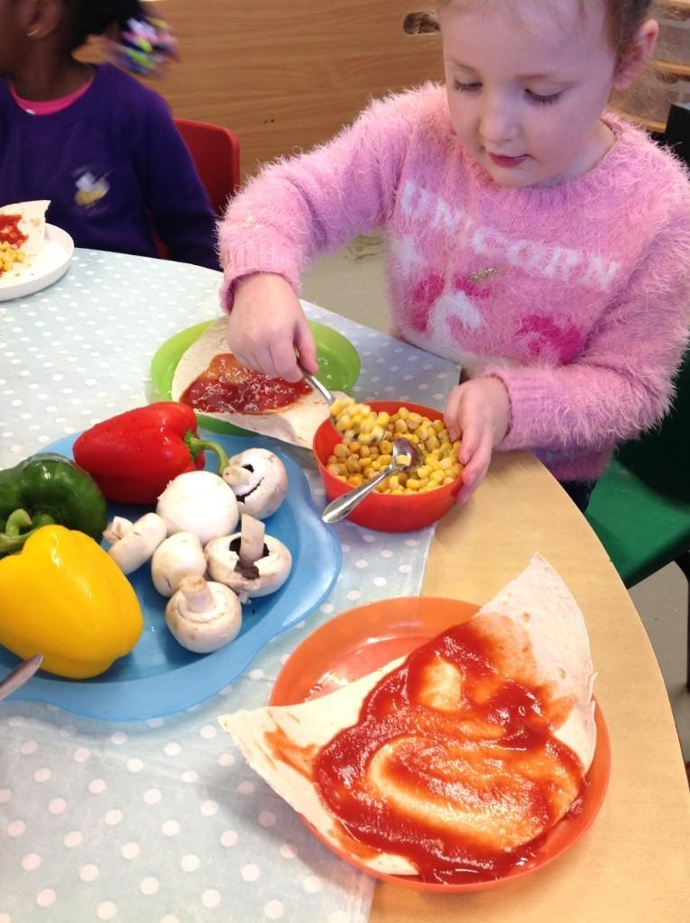

Early Years Funding and fee payments
Funding
3 Year Olds & 4 Year Olds
Each child is entitled to claim nursery funding for 15 hours a week, spread over 2 days or more, from the term after their 3rd birthday. The free entitlement is for 38 weeks a year. We also offer 30 hour funding, for those that are entitled to it.
2 Year Olds
At Beaumont Community Preschool & Childcare Groups we offer 2 year old funding that allows eligible children to receive free early years education from the term after their second birthday. To review the eligibility criteria then please follow this link.
http://www.hants.gov.uk/socialcareandhealth/children and families/childcare/paying for childcare/freechildcare/2yearoldoffer
Early Years Pupil Premium
Three and four year old children attending an early year’s education setting may be eligible to receive Early Years Pupil Premium (EYPP). Providers could claim an additional £302 per year for each child to spend on supporting their development, learning and care.
For more information please see: http://www.hants.gov.uk/socialcareandhealth/children andfamilies/childcare
If you do believe your child is entitled then please let us know and we can organise the paperwork.
Fees and invoicing
For those parents whose children are not eligible for funding, and for those wanting extra session, fees are payable in advance either the week before or at the beginning of every week or month your child attends
Parents/carers who pay will need to pay a deposit of 2 weeks fees when they hand in their admission form and before your child leaves the setting we do require 2 weeks’ notice whether you receive funding or are paying
Fees should to be brought into the office area; there is also a post box outside the office door for fees.
We will issue an invoice at the start of each term based on the sessions requested. We will also ask you to complete the parent form for funding if applicable. We ask that payment of the invoice is prompt. We accept cash, cheque, bank transfer and most childcare vouchers.
sESSION rATE (EVERY 3 HOURS)
3 and 4 year olds- £15.00
2 year olds- £18.00
Under 2 year olds- Half Day (3 hours) £21.00 and Full Day (6 hours) £42.00
Uniform
Uniform can be purchased but is not compulsory to wear, we offer t-shirts, jumpers, book bags, hats and water bottles; please ask at the office for more information on prices.

